E5: Concentric Circles

Course: IGME 309 – Real Time Simulations for Games II

Golisano College of Computing and Information Sciences

School of Interactive Games and Media

Rochester Institute of Technology

Due: Check in MyCourses

Deliverable: Mesh.cpp file (single file, unzipped)

**Objective:**

The objective of this exercise is for students to develop a function that generates three-dimensional concentric circles and rotates them around the Y-axis to construct a sphere. This assignment is intended to reinforce concepts in 3D geometry, rotations, and parametric modeling. By completing this exercise, students will gain hands-on experience with the following:

* Understanding the mathematical principles behind 3D rotations, particularly around the Y-axis.
* Applying parametric equations to generate 3D shapes based on a series of 2D circles.
* Visualizing how the rotation of concentric circles around an axis can lead to the creation of complex shapes, such as spheres.
* Implementing transformations in 3D space and using them to model geometries in graphics programming.
* Gaining proficiency with techniques for creating 3D objects using iterative processes and geometric construction methods.

The exercise will allow students to build a foundational understanding of spherical coordinate systems and how they relate to generating 3D objects for graphics and simulation.

**Instructions:**

This exercise follows lecture D05

1. In the root of the repository look for the example execution under _Binary. It will look like this:

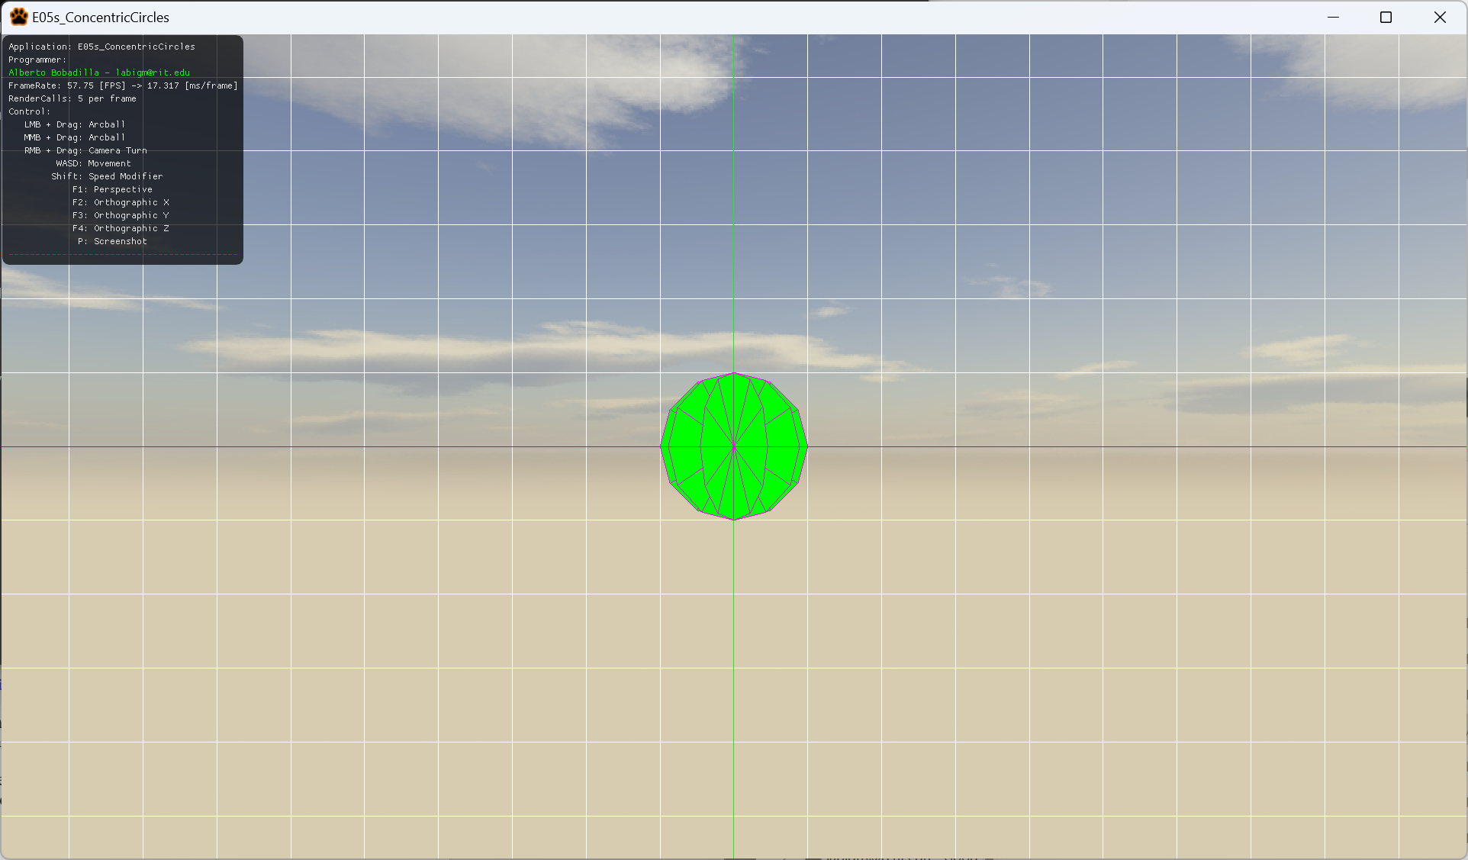

1. For this exercise you will create a dynamic number of circles that will share an origin point, you may create the circles calculating by trigonometry or use a rotation matrix from glm to arrange the new circles. It is up to you to ideate the solution for the exercise. Remember you will be using a method that uses this signature:

void GenerateCCircles(float a_fRadius, int a_nSubdivisions, int a_nCircles, vector3 a_v3Color);

The number of subdivisions as you can see is the same number of triangles and the radius is how large is the circle, along with the color of the shape. The number of circles you can see in a full revolution around the origin is a_nCircles

1. All your code will be coded in the mesh.cpp file in said function so this is the only file you need to submit to the dropbox in MyCourses, please do not zip this file.

